DPCT1011 Analysis

Total number of 1011 warning： 20

Total number of projects have this warning: 3

Total number of files have this warning: 3

Number of projects miss the dpct-version: 2

Number of files miss the dpct-version: 2

Available projects have this warning: 1

Available files have this warning: 1

Available data: 8

|  |  |
| --- | --- |
| Message_id | Message |
| 54 | The tool detected overloaded operators for built-in vector types, which may conflict with the SYCL 1.2.1 standard operators (see 4.10.2.1 Vec interface). The tool inserted a namespace to avoid the conflict. Use SYCL 1.2.1 standard operators instead. |

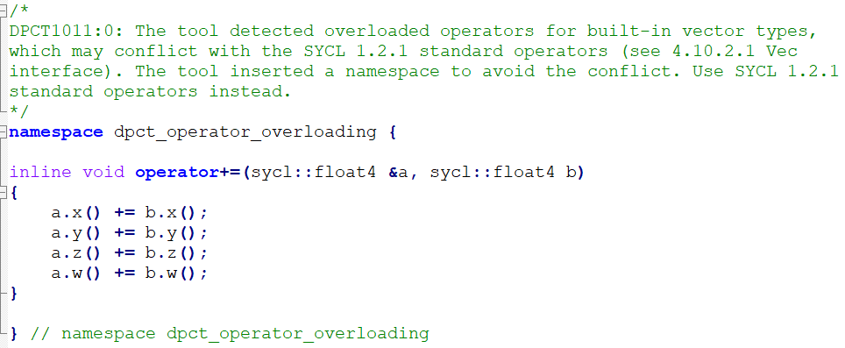

Only one project has the cpp file, and it just delete the namespace.

